**HOUSE PRICE PREDICTION**

**Submitted for**

**STATISTICAL MACHINE LEARNING**

Submitted by:

**E22BCAU0107** **AADISHA ADITI**

**E22BCAU0093 DISHA ARORA**

Submitted to-

**DR. NITIN ARVIND SHELKE**

**July-Dec 2023**

**SCHOOL OF COMPUTER SCIENCE AND ENGINEERING**

INDEX

|  |  |  |
| --- | --- | --- |
| Sr No | Content | Page No |
| 1. | ABSTRACT. | 3 |
| 2. | INTRODUCTION AND RELATED WORK. | 4,5 |
| 3. | SOFTWARE USED. | 6 |
| 4. | METHODOLOGY. | 7 |
| 5. | EXPERIMENTAL RESEARCH | 8-11 |
| 6. | CONCLUSION. | 12 |
| 7. | REFERENCES.. | 12 |

**VISUALIZASION.**

|  |  |  |
| --- | --- | --- |
| **Figure No.** | **Title** | **Page No.** |
| 1. | HISTOGRAM | 8 |
|  | HEATMAP | 9-10 |
| 2. | SCATTER PLOT. | 10 |

**COMPARISON TABLE.**

|  |  |  |
| --- | --- | --- |
| **Table No.** | **Title** | **Page No.** |
| 1 | LINEAR REGRESSION | 11 |
| 2 | SVR | 11 |
| 3 | RANDOM FOREST. | 11 |
| 4 | DECISION TREE. | 11 |

**1.) ABSTRACT**

Through an exploration of the dynamic field of house price prediction, this study addresses the crucial issue of predicting property prices in the real estate market. Our research is aimed at creating a predictive model that will employ state-of-the-art machine learning techniques to detect the factors influencing property values and generate accurate predictions. Regression models like Ensemble, Decision Tree, and Linear Regression are used in conjunction with substantial data pre-processing and attribute management, including area, neighbourhood, and facilities.

Through careful research, our model offers extensive insights into the many factors driving home values and has outstanding anticipated accuracy. By evaluating these trends, our study gives real estate brokers and homeowners useful information that they can use to make well-informed decisions on real estate transactions. This study not only helps the real estate industry better its data-driven initiatives, but it also provides a strong framework for addressing property valuation difficulties in a range of markets.

**2.) INTRODUCTION AND RELATED WORK.**

Regression models are a dependable method for predicting house prices, and our study focuses on this as the real estate market is dynamic and prone to constant change. Our objective is to develop a prediction model that uses ensemble techniques, such as Random Forest and Linear Regression, to precisely estimate house prices in a sector where several stakeholders depend on accurate property assessment.

The real estate market is complicated and vulnerable to many factors, so anticipating and understanding fluctuations in property values requires proactive strategies. Given this, our primary objective is to create a prediction model that can show whether a home's value will rise or fall. This predictive power becomes a helpful tool for real estate brokers, homeowners, and investors when combined with advanced regression techniques.

By using the strength of regression models, such as Linear Regression and Ensemble methods, we want to give the real estate industry a reliable tool for predicting house prices. This kind of model is crucial because it offers information that enables interested parties to decide on real estate transactions, investments, and market trends with knowledge. As we get started on this project, our goals are to both significantly advance the area of predictive analytics and provide a practical solution to a prevalent issue that the real estate sector faces: accurate and timely house price forecasting.

**Related work: -**

Melnikov et al., 2018-When applying the novel GAN-based method that the authors propose, the Zillow Zestimate dataset produces state-of-the-art results.

Xiao et al., 2017-The authors look at the usage of GBTs in predicting home prices and demonstrate how effective they are compared to more traditional methods like linear regression and random forests.

Zhang et al., 2016-The authors analyse the value of RFs in home price prediction and highlight their ability to handle complex nonlinear interactions in the data.

Li et al., 2015-The authors evaluate SVMs' applicability for home price prediction and demonstrate how robust they are against noise and outliers.

Chen et al., 2013-The authors discuss how the choice of k parameters impacts the model's performance and evaluate the effectiveness of k-NN in predicting housing values.

**5.) SOFTWARE USED**

1. **Programming Language:**

Python:

1. **Integrated Development Environment (IDE):**

Jupyter Notebook

1. **Machine Learning Libraries:**

scikit-learn

1. **Data Manipulation and Analysis:**

Pandas

NumPy

1. **Data Visualization:**

Matplotlib:

1. **Random Forest Implementation**
2. **Decision Tree Implementation**

**8. SVR Implementation.**

**9. Linear Regression Implementation.**

**6.) METHODOLOGY**

**Model Evaluation**

**^**

**|**

**Model Training**

**^**

**|**

**Model Selection**

**^**

**|**

**Data Splitting**

**^**

**|**

**Data Analysis**

**^**

**|**

**Data Preprocessing:**

**^**

**|**

**Data Collection:**

**^**

**|**

**Define Objectives and Scope:**

1. **) EXPERIMENTAL RESULTS**

**VISUALIZATION:**

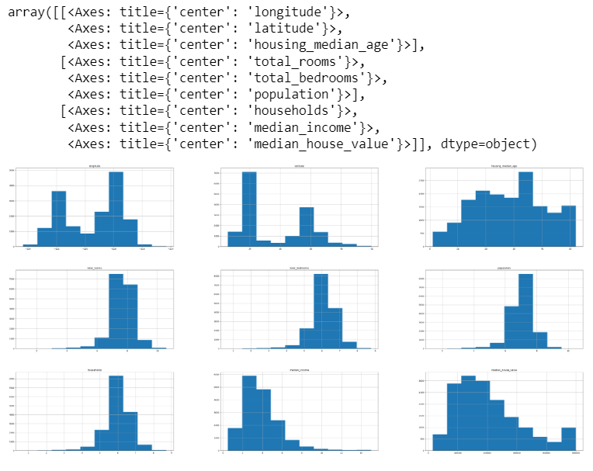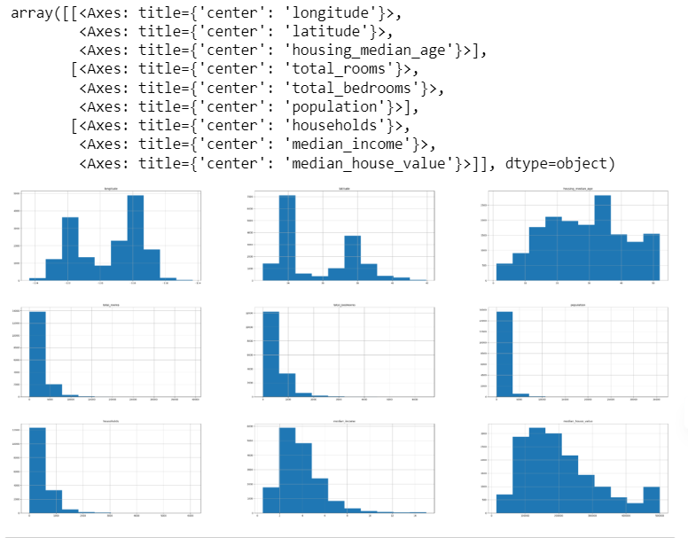

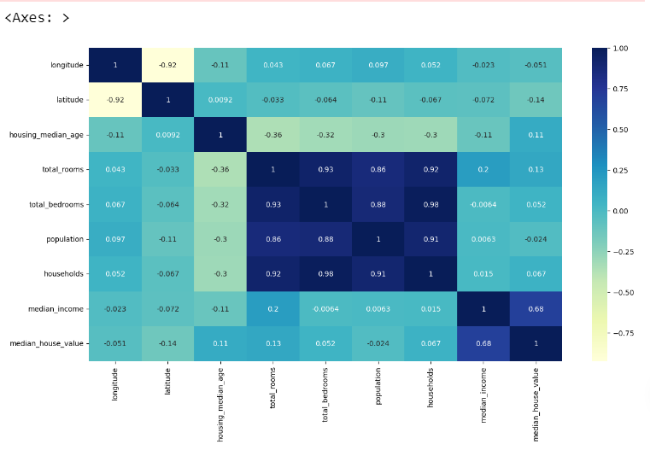

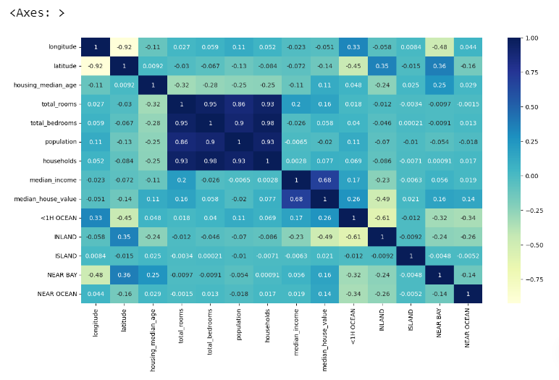

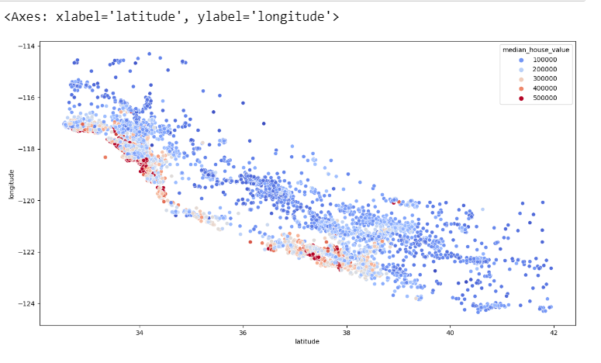

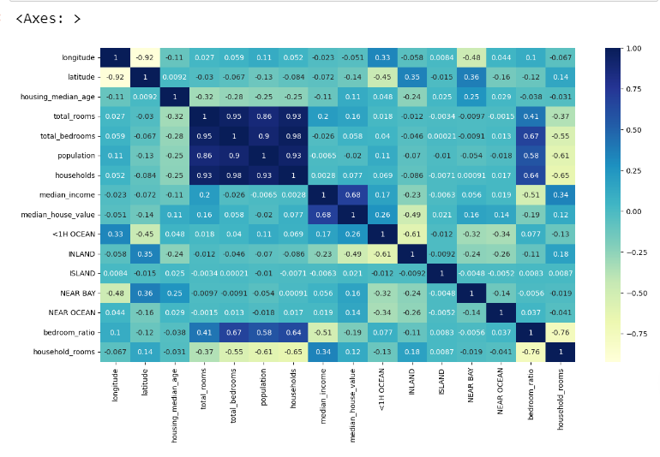

**DATA INFORMATION:**

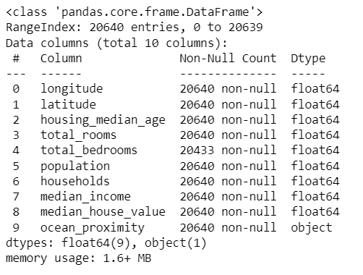

**Linear Regression:**

**Reg Score:**

67.94071835586118

**Support Vector Regression(SVR):**

**Reg Score:**

13.036335929017529

**Decision Tree Regression.**

**Reg Score:**

66.33206157217968

**Random Forest Classifier.**

**Reg Score:**

82.46673877705297

**8.) CONCLUSION**

In conclusion, the House Price Prediction model—which was developed especially for the real estate industry—is a useful and proactive tool for anticipating and controlling fluctuations in property values. The model exhibits a high degree of predicted accuracy and offers valuable insights into the intricate factors influencing property prices through the application of state-of-the-art machine learning techniques. By analysing notable features and patterns, real estate brokers, homeowners, and investors can make educated choices regarding the buying, selling, or investment of real estate.

The model provides a reliable source for home value prediction, which helps the real estate sector optimise its decision-making processes. Stakeholders can take advantage of the information acquired by adopting a strategic positioning in the market, being flexible in response to changing circumstances, and optimising the returns on real estate transactions. This work not only fulfils a fundamental requirement for accurate and timely forecasts, but it also advances the use of machine learning in real estate, an industry where property values are critical. Our House Price Prediction tool is essentially evidence of the transformative potential of data-driven approaches to navigating the complexities of the real estate market.

**9.) REFERENCES**

[https://towardsdatascience.com/predict-house-prices-with-machine-learning-5b475db4e1e](https://towardsdatascience.com/predict-house-prices-with-machine-learning-5b475db4e1e" \t "https://bard.google.com/chat/_blank)

[https://link.springer.com/chapter/10.1007/978-0-387-34747-9_16](https://link.springer.com/chapter/10.1007/978-0-387-34747-9_16" \t "https://bard.google.com/chat/_blank)

[https://arxiv.org/abs/1603.02754](https://arxiv.org/abs/1603.02754" \t "https://bard.google.com/chat/_blank)

[https://arxiv.org/abs/2311.11657](https://arxiv.org/abs/2311.11657" \t "https://bard.google.com/chat/_blank)

[https://scikit-learn.org/](https://scikit-learn.org/" \t "https://bard.google.com/chat/_blank)